**DAILY ONLINE ACTIVITIES SUMMARY**

|  |  |  |  |  |  |  |  |  |
| --- | --- | --- | --- | --- | --- | --- | --- | --- |
| **Date:** | **23-05-2020** | | | | | **Name:** | **Raksha S** | |
| **Sem & Sec** | **6th B** | | | | | **USN:** | **4AL17CS073** | |
| **Online Test Summary** | | | | | | | | |
| **Subject** | | **Python Application & Programming** | | | | | | |
| **Max. Marks** | | **30** | | **Score** | | | **18** | |
| **Certification Course Summary** | | | | | | | | |
| **Course** | **FullStack Webdevelopment & CyberSecurity Specialisation** | | | | | | | |
| **Certificate Provider** | | | **Gratlearning**  **udemy** | | **Duration** | | | **45days**  **40 days** |
| **Coding Challenges** | | | | | | | | |
| Problem Statement: 1. Write a java program to implement round robin scheduling algorithm.Calculate AVG WT AND TAT. INPUT:NO OF PROCESSES,BURST TIME AND TIME QUANTUM.  2. Write a Java Program to separate the Individual Characters from a String | | | | | | | | |
| **Status:** YES, Completed all Programs | | | | | | | | |
| **Uploaded the report in Github** | | | | | **YES** | | | |
| **If yes Repository name** | | | | | https://github.com/raksha05/[Daily-Status](https://github.com/raksha05/Daily-Status)/[Raksha 4AL17CS073](https://github.com/raksha05/Daily-Status/tree/master/Raksha%204AL17CS073)/**Raksha** | | | |
| **Uploaded the report in slack** | | | | | **YES** | | | |

Online Test Details:

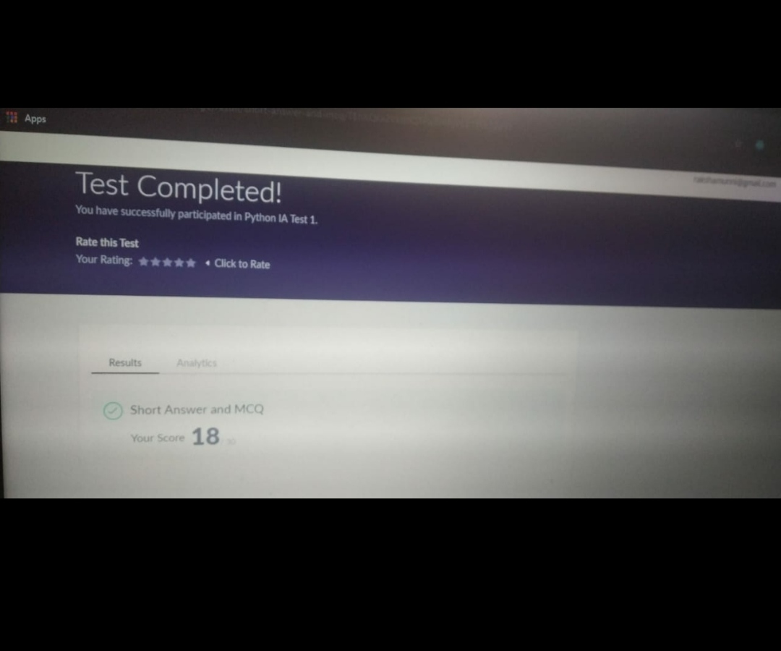

Scored 18 out of 30 in Python 1st I.A test

Certification Course Details:

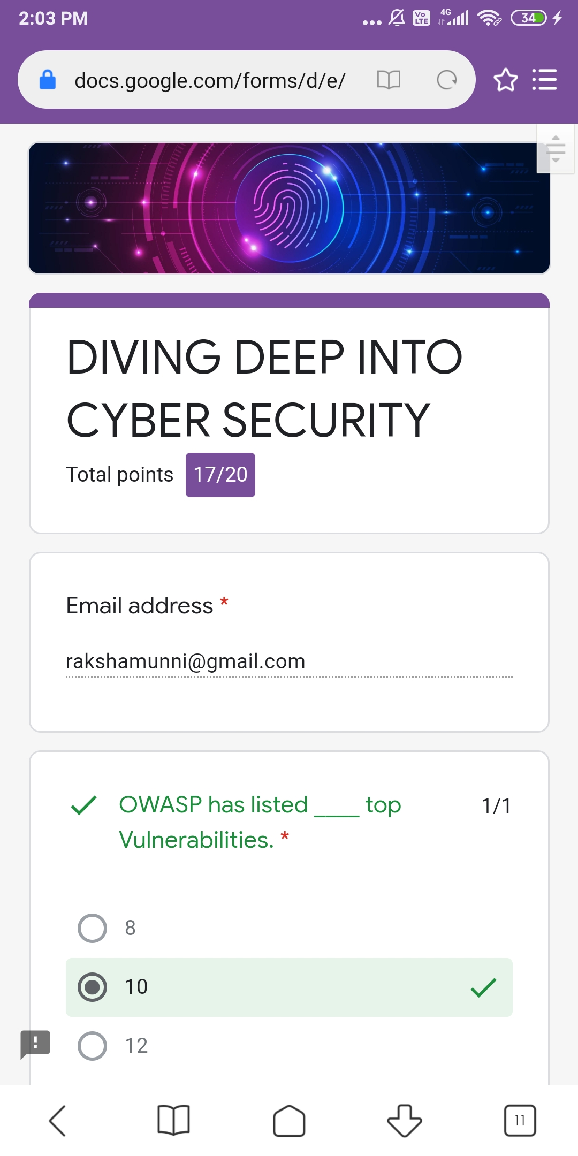

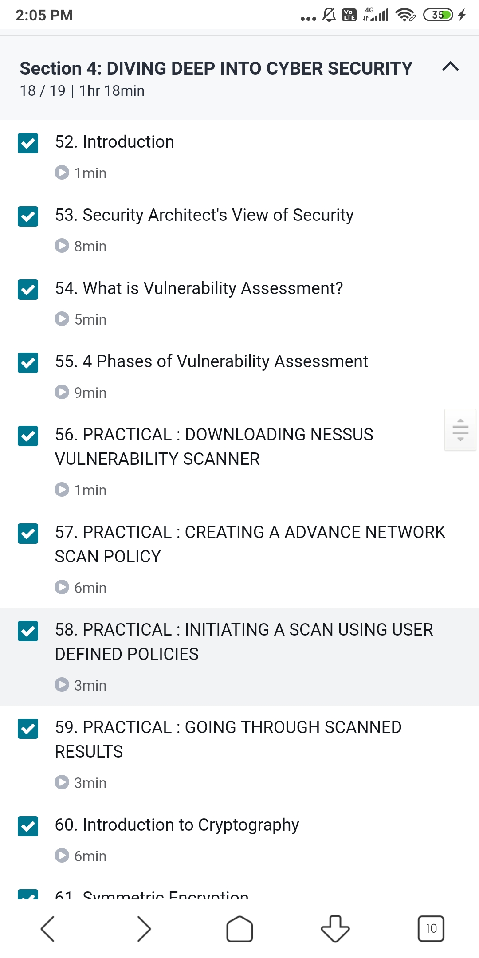

The above course is being taken up by me is based on Cyber Security Specialisation . Today in online course I studied about security architect’s view of security,vulnerable assessment,about cryptography.Based on this one assignment quiz was given in which I scored 17 out of 20.

Coding Challenges Details:

Program1:

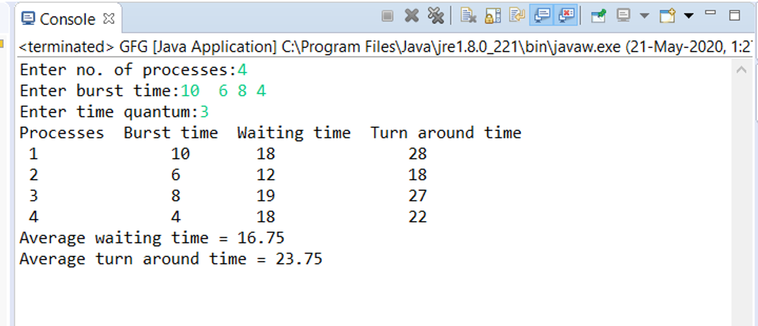

Program2:

